Natural Logarithms

The natural logarithm of a number is its logarithm to the base of the mathematical constant (**e**)

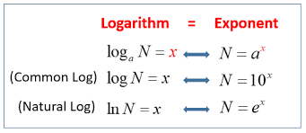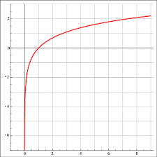

when we use **e** as our base for a logarithm , we call it a natural logarithm depending on the platform we may use **ln ()** instead of log() to specify a natural logarithm so rather than express a natural logarithm expressed as log e 10 to find the power raised on **e** to get 10 , we would shorthand it as *ln(10):*

*loge10=ln(10)*

how ever in python a natural language is specified by the log() function

the default base for the log() function is **e**

**python file : 1.ipynb**

